Panchromatic Urban Settlement Indices Implementation on ROI Image (Bahria Town Phase 7)

First of all region of interest was selected and then image of landsat 8 and segmentation mask was constructed using Google Earth Engine (GEE). Dynamic World Labels classes were used as classes for the mask. Dynamic World Labels has class names:
- Water
- Trees
- Grass
- Flooded Vegetation
- Crops
- Shrub & Scrub
- Built
- Bare
- Snow & Ice
The code used for extraction was:

// 1. Define ROI
var roi = ee.Geometry.Point(73.11988, 33.53081).buffer(2000);
Map.centerObject(roi, 14);

// 2. Load Dynamic World (Jan 2023 - Jun 2025)
var dw = ee.ImageCollection('GOOGLE/DYNAMICWORLD/V1')
.filterBounds(roi)
.filterDate('2023-01-01', '2025-06-30');

// 3. Landcover class mode (per pixel: most common label)
var dwLabels = dw.select('label').mode();

// 4. (Optional) Visualize: color palette for Dynamic World
var dwPalette = [
'#419bdf', // 0 Water
'#397d49', // 1 Trees
'#88b053', // 2 Grass
'#7a87c6', // 3 Flooded Vegetation
'#e49635', // 4 Crops
'#dfc35a', // 5 Shrub & Scrub
'#c4281b', // 6 Built
'#a59b8f', // 7 Bare
'#ffffff' // 8 Snow & Ice
];
Map.addLayer(
dwLabels.clip(roi),
{min: 0, max: 8, palette: dwPalette},
'Dynamic World Landcover (mode)'
);

// 5. Landsat-8 TOA, least-cloudy scene
var l8 = ee.ImageCollection('LANDSAT/LC08/C02/T1_TOA')
.filterBounds(roi)
.filterDate('2023-01-01', '2025-06-30')
.sort('CLOUD_COVER')
.first();

// 6. Select all 11 bands (B1 to B11)
var allBands = l8.select([
'B1','B2','B3','B4','B5','B6','B7','B8','B9','B10','B11'
]);

// 7. (Optional) Visualize Landsat-8 RGB
Map.addLayer(
allBands.clip(roi),
{bands: ['B4','B3','B2'], min: 0.05, max: 0.4},
'Landsat-8 RGB'
);

// 8. EXPORT: Full 11-band Landsat-8 image
Export.image.toDrive({
image: allBands.clip(roi),
description: 'L8_BahriaPhase7_11Bands',
folder: 'GEE_Exports',
fileNamePrefix: 'L8_BahriaPhase7_11Bands_' + l8.date().format('yyyyMMdd').getInfo(),
region: roi,
scale: 30, // Landsat-8 native resolution
crs: 'EPSG:4326',
maxPixels: 1e10
});

// 9. EXPORT: Dynamic World label raster (all classes)
Export.image.toDrive({
image: dwLabels.clip(roi),
description: 'DynamicWorld_LandcoverLabels',
folder: 'GEE_Exports',
fileNamePrefix: 'DynamicWorld_LandcoverLabels',
region: roi,
scale: 10, // Dynamic World native resolution
crs: 'EPSG:4326',
maxPixels: 1e10
});

After downloading the images and masks. I viewed the images and masks:
import rasterio
import numpy as np
import matplotlib.pyplot as plt

# === 1. Load Landsat 8 Image (11 bands) ===
landsat_path = r'C:\Users\Adeel Ajmal\Downloads\L8_BahriaPhase7_20231012.tif'

with rasterio.open(landsat_path) as src:
landsat = src.read().astype('float32') # shape: (11, H, W)
profile = src.profile
print("Landsat shape (bands, rows, cols):", landsat.shape)

# Landsat 8: B4 (red), B3 (green), B2 (blue) — 0-based indices: 3, 2, 1
red = landsat[3]
green = landsat[2]
blue = landsat[1]
rgb = np.stack([red, green, blue], axis=-1) # shape: (rows, cols, 3)

# Stretch RGB for display (robust, 2-98%)
valid = np.isfinite(rgb)
rgb_min = np.nanpercentile(rgb[valid], 2)
rgb_max = np.nanpercentile(rgb[valid], 98)
rgb = np.clip((rgb - rgb_min) / (rgb_max - rgb_min), 0, 1)
rgb[~valid] = 0 # set nodata to black

plt.figure(figsize=(6,6))
plt.imshow(rgb)
plt.title("Landsat 8 Natural Color (B4, B3, B2)")
plt.axis('off')
plt.show()

# === 2. Load Dynamic World Label Raster ===
label_path = r'C:\Users\Adeel Ajmal\Downloads\DynamicWorld_LandcoverLabels.tif'
with rasterio.open(label_path) as src:
labels = src.read(1)

# === 3. Visualize Dynamic World All-Class Map ===
palette = np.array([
[65, 155, 223], # 0 Water
[57, 125, 73], # 1 Trees
[136, 176, 83], # 2 Grass
[122, 135, 198], # 3 Flooded Vegetation
[228, 150, 53], # 4 Crops
[223, 195, 90], # 5 Shrub & Scrub
[196, 40, 27], # 6 Built (urban)
[165, 155, 143], # 7 Bare
[255, 255, 255], # 8 Snow & Ice
]) / 255.

label_rgb = palette[labels]
plt.figure(figsize=(6,6))
plt.imshow(label_rgb)
plt.title("Dynamic World Landcover (All Classes)")
plt.axis('off')
plt.show()

# === 4. Create and Show Urban vs Non-Urban Mask ===
urban_mask = (labels == 6)
plt.figure(figsize=(6,6))
plt.imshow(urban_mask, cmap='gray')
plt.title("Urban (Built-up) Mask (1 = urban, 0 = non-urban)")
plt.axis('off')
plt.show()

Output:
Landsat shape (bands, rows, cols): (11, 134, 160)
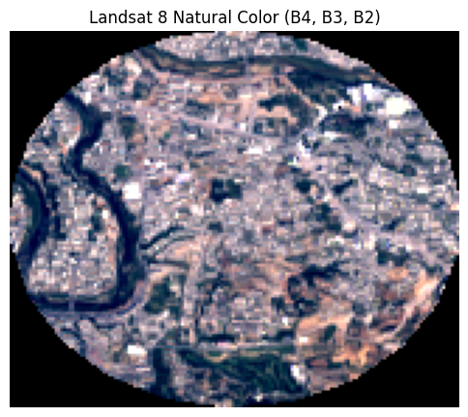
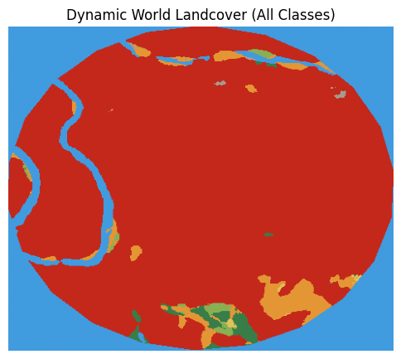

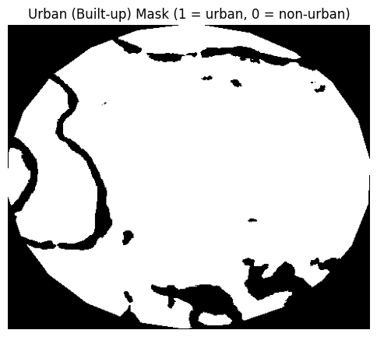

Landsat 8 Bands:
Band Number | Band Name | Wavelength (µm) | Spatial Resolution (m)
1 | Coastal /Aerosol | 0.43–0.45 | 30
2 | Blue | 0.45–0.51 | 30
3 | Green | 0.53–0.59 | 30
4 | Red | 0.64–0.67 | 30
5 | NIR | 0.85–0.88 | 30
6 | SWIR 1 | 1.57–1.65 | 30
7 | SWIR 2 | 2.11–2.29 | 30
8 | PAN (Panchromatic) | 0.50–0.68 | 15
9 | Cirrus | 1.36–1.38 | 30
10 | TIRS 1 (Thermal) | 10.6–11.19 | 100
11 | TIRS 2 (Thermal) | 11.50–12.51 | 100

Panchromatic Urban Settlement Indices:
- Modified Normalized Difference Soil Index (MNDSI)
- Ratio Urban Index (RUI)
- Normalized Ratio Urban Index (NRUI)
The formulas of the three are:

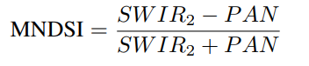
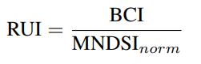
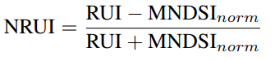
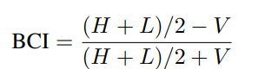

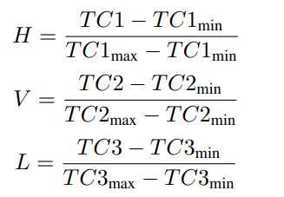

Here TC1, TC2 and TC3 are Tasseled Cap Coeficients for Landsat 8.
The code used for implementation is:
import rasterio
import numpy as np
import matplotlib.pyplot as plt
from matplotlib.colors import ListedColormap
from sklearn.metrics import (
jaccard_score, confusion_matrix, accuracy_score, precision_score,
recall_score, f1_score, balanced_accuracy_score, cohen_kappa_score,
roc_curve, auc
)
from skimage.transform import resize
import pandas as pd
import matplotlib.patches as mpatches
import os

# ======= Settings =======
landsat_path = r'C:\Users\Adeel Ajmal\Downloads\L8_BahriaPhase7_20231012.tif'
label_path = r'C:\Users\Adeel Ajmal\Downloads\DynamicWorld_LandcoverLabels.tif'
outdir = "urban_index_eval"
save_figs = True
os.makedirs(outdir, exist_ok=True)

# ======= 1. Load Data =======
with rasterio.open(landsat_path) as src:
stack = src.read().astype('float32')
b1,b2,b3,b4,b5,b6,b7,b8,b9,b10,b11 = stack

with rasterio.open(label_path) as src:
labels = src.read(1)

gt_mask = (labels == 6).astype(np.uint8)
gt_mask_resized = resize(
gt_mask,
(stack.shape[1], stack.shape[2]),
order=0, preserve_range=True, anti_aliasing=False
).astype(np.uint8)

# ======= 2. Indices =======
mndsi = (b7 - b8) / (b7 + b8 + 1e-6)
ndvi = (b5 - b4) / (b5 + b4 + 1e-6)
TC1 = (0.3029*b2 + 0.2786*b3 + 0.4733*b4 + 0.5599*b5 + 0.5080*b6 + 0.1872*b7)
TC2 = (-0.2941*b2 - 0.2430*b3 - 0.5424*b4 + 0.7276*b5 + 0.0713*b6 - 0.1608*b7)
TC3 = (0.1511*b2 + 0.1973*b3 + 0.3283*b4 + 0.3407*b5 - 0.7117*b6 - 0.4559*b7)
norm = lambda a: (a - np.nanmin(a)) / (np.nanmax(a) - np.nanmin(a) + 1e-6)
H, V, L = norm(TC1), norm(TC2), norm(TC3)
bci = ((H + L)/2 - V) / ((H + L)/2 + V + 1e-6)
rui = bci / (mndsi + 1e-6)
nrui = (rui - mndsi) / (rui + mndsi + 1e-6)
for arr in (mndsi, ndvi, bci, rui, nrui): arr[~np.isfinite(arr)] = np.nan

indices = {"MNDSI": mndsi, "BCI": bci, "RUI": rui, "NRUI": nrui}

# ======= 3. NDVI Threshold Search & Best Mask =======
ndvi_thresholds = np.arange(0.1, 0.81, 0.05)
best_results = {}
all_results = {}

def best_threshold(idx, truth, n_steps=200):
v = np.isfinite(idx) & np.isfinite(truth)
x, y = idx[v].ravel(), truth[v].ravel()
best_thr, best_iou = None, -1
for thr in np.linspace(np.nanmin(x), np.nanmax(x), n_steps):
y_pred = (x > thr).astype(np.uint8)
if y_pred.sum() == 0: continue
iou = jaccard_score(y, y_pred, zero_division=0)
if iou > best_iou: best_thr, best_iou = thr, iou
return best_thr

def metrics(mask_pred, truth, idx_pred_scores=None):
v = np.isfinite(mask_pred) & np.isfinite(truth)
y_pred, y_true = mask_pred[v].ravel(), truth[v].ravel()
out = dict(
IoU=jaccard_score(y_true, y_pred, zero_division=0),
F1=f1_score(y_true, y_pred, zero_division=0),
Pr=precision_score(y_true, y_pred, zero_division=0),
Re=recall_score(y_true, y_pred, zero_division=0),
Acc=accuracy_score(y_true, y_pred),
BAc=balanced_accuracy_score(y_true, y_pred),
Kappa=cohen_kappa_score(y_true, y_pred)
)
tn, fp, fn, tp = confusion_matrix(y_true, y_pred, labels=[0,1]).ravel()
out.update({"TP":tp,"TN":tn,"FP":fp,"FN":fn})
# Robust ROC/AUC
if idx_pred_scores is not None:
v2 = v & np.isfinite(idx_pred_scores)
y_true2 = truth[v2].ravel()
y_score2 = idx_pred_scores[v2].ravel()
if len(np.unique(y_true2)) > 1 and len(y_score2) > 0:
try:
fpr, tpr, _ = roc_curve(y_true2, y_score2)
out["AUC"] = auc(fpr, tpr)
except Exception as e:
out["AUC"] = np.nan
else:
out["AUC"] = np.nan
else:
out["AUC"] = np.nan
return out

for idx_name, idx in indices.items():
metric_by_thr = []
for ndvi_thr in ndvi_thresholds:
thr = best_threshold(idx, gt_mask_resized)
pred = ((idx > thr) & (ndvi < ndvi_thr)).astype(np.uint8)
result = metrics(pred, gt_mask_resized, idx_pred_scores=idx)
result['ndvi_thr'] = ndvi_thr
result['idx_thr'] = thr
metric_by_thr.append(result)
df_thr = pd.DataFrame(metric_by_thr)
best_i = df_thr['IoU'].idxmax()
best_results[idx_name] = df_thr.loc[best_i].to_dict()
all_results[idx_name] = df_thr

# ======= 4. Visualization: 3-panel for Each Index =======
# Prepare color palettes for GT
class_palette = [
"#419bdf", "#397d49", "#88b053", "#7a87c6", "#e49635",
"#dfc35a", "#c4281b", "#a59b8f", "#ffffff"
]
class_names = [
"Water", "Trees", "Grass", "Flooded Veg", "Crops",
"Shrub/Scrub", "Built", "Bare", "Snow/Ice"
]
label_viz = resize(labels, (stack.shape[1], stack.shape[2]), order=0, preserve_range=True, anti_aliasing=False)

# Prepare RGB for overlays
rgb = np.stack([b4, b3, b2], -1)
p2, p98 = np.nanpercentile(rgb, (2, 98))
rgb = np.clip((rgb - p2) / (p98 - p2), 0, 1)
rgb[np.isnan(rgb)] = 0

# Color definitions for overlay
URBAN_COLOR = np.array([1.0, 0.1, 0.1]) # bright red
NON_URBAN_COLOR = np.array([0.65, 0.65, 0.65]) # light gray

for idx_name, idx in indices.items():
best = best_results[idx_name]
ndvi_thr = best['ndvi_thr']
idx_thr = best['idx_thr']
pred = ((idx > idx_thr) & (ndvi < ndvi_thr)).astype(np.uint8)

# --- Panel 1: Landsat RGB ---
fig, axs = plt.subplots(1, 3, figsize=(22, 7))
axs[0].imshow(rgb)
axs[0].set_title("Landsat-8 RGB")
axs[0].axis('off')

# --- Panel 2: Dynamic World classes with legend ---
im2 = axs[1].imshow(label_viz, cmap=ListedColormap(class_palette), vmin=0, vmax=8)
axs[1].set_title("Dynamic World Labels")
axs[1].axis('off')
cbar = plt.colorbar(im2, ax=axs[1], ticks=np.arange(0,9), shrink=0.8)
cbar.ax.set_yticklabels(class_names)

# --- Panel 3: Urban/Non-Urban mask overlays on grayscale index image ---
idx_disp = np.copy(idx)
idx_disp[~np.isfinite(idx_disp)] = np.nan
axs[2].imshow(idx_disp, cmap='gray')

# Overlay: GT mask (cyan), prediction (red), all others (gray)
gt_viz = np.zeros((*gt_mask_resized.shape, 3), dtype=np.float32)
gt_viz[gt_mask_resized == 1] = URBAN_COLOR
gt_viz[gt_mask_resized == 0] = NON_URBAN_COLOR
pred_viz = np.zeros((*pred.shape, 3), dtype=np.float32)
pred_viz[pred == 1] = URBAN_COLOR
pred_viz[pred == 0] = NON_URBAN_COLOR
axs[2].imshow(0.6*gt_viz + 0.4*pred_viz, alpha=0.45)
axs[2].set_title(f"{idx_name} Index\nIoU={best['IoU']:.3f} NDVI<{ndvi_thr:.2f}")
axs[2].axis('off')

# Custom legend for third panel
handles = [
mpatches.Patch(color=URBAN_COLOR, label='Urban'),
mpatches.Patch(color=NON_URBAN_COLOR, label='Non-Urban')
]
axs[2].legend(handles=handles, loc='lower right', fontsize=12)

plt.tight_layout()
if save_figs:
plt.savefig(os.path.join(outdir, f"{idx_name}_urban3panel.png"), dpi=200, bbox_inches='tight')
plt.show()

# ======= 5. Save Summary Table =======
header = "{:<6} {:>8} {:>8} {:>8} {:>8} {:>8} {:>8} {:>8} {:>8} {:>6} {:>8}".format(
"Index","IoU","F1","Pr","Re","Acc","BAc","Kappa","AUC","TP","NDVI_thr")
print(header)
print("-"*len(header))
for k,v in best_results.items():
print("{:<6} {:8.3f} {:8.3f} {:8.3f} {:8.3f} {:8.3f} {:8.3f} {:8.3f} {:8.3f} {:6.0f} {:8.2f}".format(
k, v['IoU'], v['F1'], v['Pr'], v['Re'], v['Acc'], v['BAc'], v['Kappa'], v['AUC'], v['TP'], v['ndvi_thr']))
df = pd.DataFrame(best_results).T
df.to_csv(os.path.join(outdir, "urban_index_metrics_best.csv"))
for k, df_thr in all_results.items():
df_thr.to_csv(os.path.join(outdir, f"{k}_ndvi_threshold_sweep.csv"))
print("GT Urban Fraction: {:.2%}".format(gt_mask_resized.mean()))
print("Predicted Urban Fraction (Best Index): {:.2%}".format(pred.mean()))
import collections
import numpy as np

# Assuming label_viz is the resized Dynamic World labels (int, 0–8)
vals, counts = np.unique(label_viz.astype(int), return_counts=True)
total = label_viz.size
print("\n--- Land Cover Breakdown (Dynamic World) ---")
for v, c in zip(vals, counts):
print(f"{class_names[v]:<12}: {c/total*100:5.2f}%")

import numpy as np
import matplotlib.pyplot as plt
from sklearn.metrics import confusion_matrix
import seaborn as sns
import os

def plot_confusion_matrix(y_true, y_pred, idx_name, outdir, labels=['Non-Urban', 'Urban']):
cm = confusion_matrix(y_true, y_pred, labels=[0,1])
plt.figure(figsize=(4,4))
sns.heatmap(cm, annot=True, fmt='d', cmap='Blues',
xticklabels=labels, yticklabels=labels,
cbar=False)
plt.xlabel('Predicted Label')
plt.ylabel('True Label')
plt.title(f'{idx_name} - Confusion Matrix')
plt.tight_layout()
# Save the figure
plt.savefig(os.path.join(outdir, f"{idx_name}_confusion_matrix.png"), dpi=150)
plt.close()

# Main loop: Go through all indices
for idx_name, idx in indices.items():
best = best_results[idx_name]
ndvi_thr = best['ndvi_thr']
idx_thr = best['idx_thr']
pred = ((idx > idx_thr) & (ndvi < ndvi_thr)).astype(np.uint8)
y_true = gt_mask_resized.ravel()
y_pred = pred.ravel()
plot_confusion_matrix(y_true, y_pred, idx_name, outdir)

print(f"Confusion matrix PNGs saved to {outdir}")

Output:
MNDSI Result:
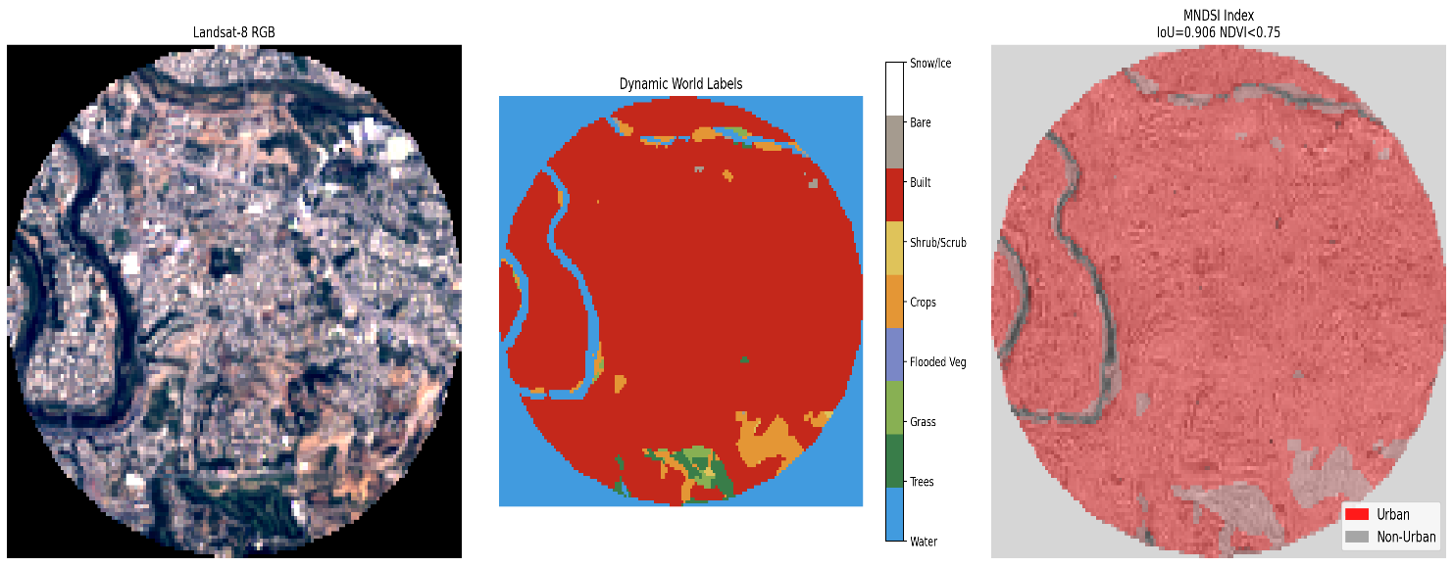
BCI Result:
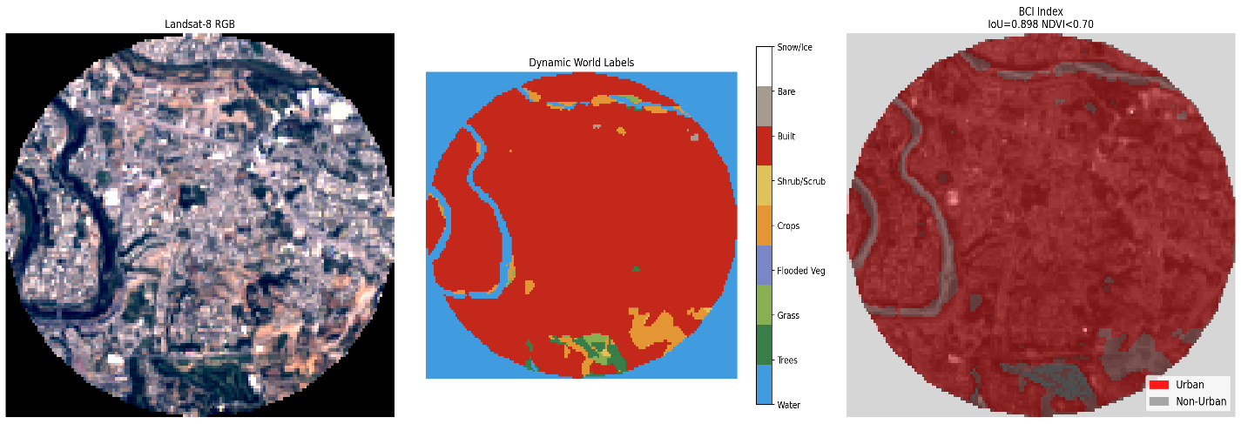
RUI Result:
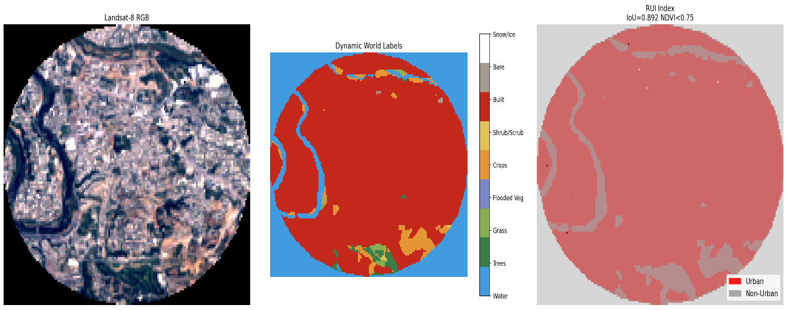

NRUI Result:
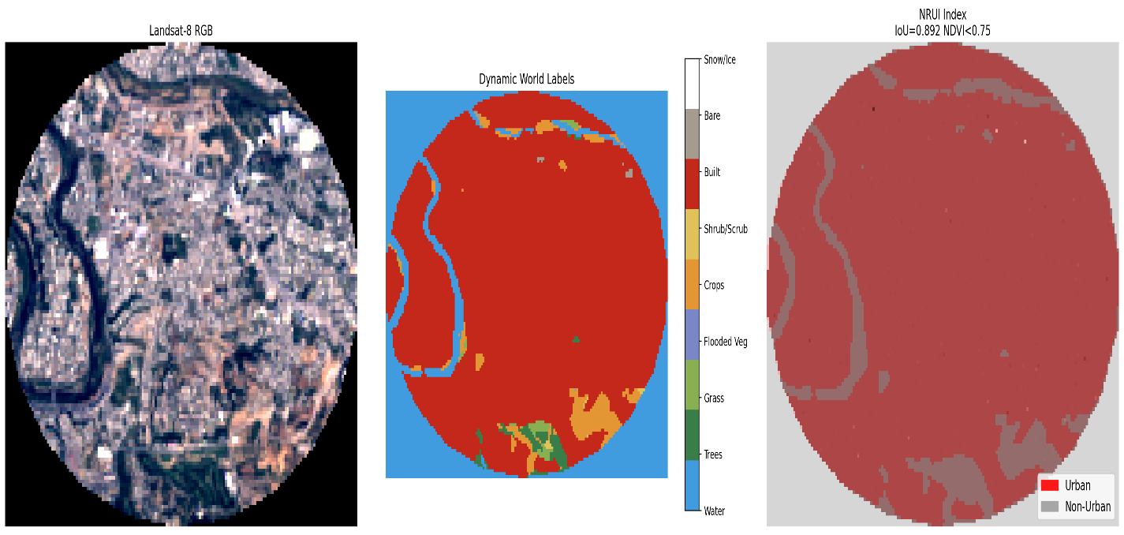
Metrics Result For Each Index:
Index Name | IoU-score | F1-score | Precision | Recall | Accuracy | Balanced Accuracy Score | Kappa Score
MNDSI | 0.906018 | 0.950692 | 0.910754 | 0.994292 | 0.927519 | 0.881973 | 0.814931
RUI | 0.891833 | 0.942824 | 0.892891 | 0.998673 | 0.914879 | 0.857723 | 0.778343
NRUI | 0.891833 | 0.942824 | 0.892891 | 0.998673 | 0.914879 | 0.857723 | 0.778343

Index Name | True Positives | True Negatives | False Positives | False Negatives | Area Under the Curve | NDVI threshold
MNDSI | 14981 | 4905 | 1468 | 86 | 0.652167 | 0.75
RUI | 15047 | 4568 | 1805 | 20 | 0.604007 | 0.75
NRUI | 15047 | 4568 | 1805 | 20 | 0.498441 | 0.75

GT Urban Fraction: 70.28%
Predicted Urban Fraction (Best Index): 78.60%

--- Land Cover Breakdown (Dynamic World) ---
- Water : 24.77%
- Trees : 1.04%
- Grass : 0.50%
- Crops : 3.18%
- Shrub/Scrub : 0.10%
- Built : 70.28%
- Bare : 0.14%
- Snow/Ice: 0%
In our Bahria Town Phase 7 ROI, Dynamic World labels 70.3% as urban (built), with a significant 24.8% as water. Our best-performing spectral index correctly identifies nearly all urban pixels, with a predicted urban fraction of 78.6% and IoU of 0.91. The majority of false positives occur in non-urban water and small vegetated areas, which is consistent with expected spectral confusion in high-density urban landscapes. Visual assessment confirms that the prediction aligns well with urban blocks and misses few true built areas, validating the index’s robustness in this context.
Confusion Matrix of Indices:
